Sports Intelligence
CSIT 337 – Internet Computing
Final Project Report – Fall 2025

1. Title Page
Team Name: Sports Intelligence
Team Leader: Joshua Babu
Team Members: Kevin Igiehon, Joshua Babu, Thanh Phan, Raiyan Shahi

2. Team Meeting Logs
· 10/05/2025 – Zoom – Project idea selection
· 10/10/2025 – Group Chat – Role assignments
· 10/18/2025 – Zoom – MVC and UI planning
· 10/25/2025 – Library – Database schema creation
· 11/01/2025 – Discord – Backend workflow mapping
· 11/10/2025 – Zoom – Final review

3. Contribution Sheet
Joshua Babu – Team leadership, backend integration (30%)
Kevin Igiehon – UI design, frontend logic, testing (25%)
Thanh Phan – Database schema and SQL design (20%)
Raiyan Shahi – Backend validation, testing, debugging (25%)

4. Teamwork Reflection
Our team collaborated effectively using Zoom, Discord, and group chat. Tasks were divided based on individual strengths, which improved efficiency. If given more time, we would increase meeting frequency earlier in the semester and perform integration testing sooner to reduce last-minute debugging.

5. Team Collaboration Score
Team collaboration score: 9/10

6. Project Summary & Mission Statement
Sports Intelligence is an AI-powered sports prediction web application that allows users to submit sports-related questions and receive probability-based predictions. The goal of the project is to provide data-driven sports insights through a secure, easy-to-use web interface.

7. Technologies Used
HTML, CSS, Bootstrap, JavaScript, PHP (PDO), MySQL, XAMPP

8. User Manual
1. Users create an account or log in.
2. Users enter a sports-related question.
3. The system validates input.
4. The AI model generates a prediction.
5. Results are displayed and stored in the database.

9. Database Schema
The database includes Users, Chats, Messages, and AI Logs tables. These tables store user credentials, conversation history, and AI responses.

10. Test Runs & Screenshots
Test runs include successful account creation, login authentication, prediction generation, and history storage. Screenshots are included in the submission.

11. YouTube Demonstration Video
https://youtu.be/h0P5KvPp3Ak

Database Schema Page:
- Database Structure:
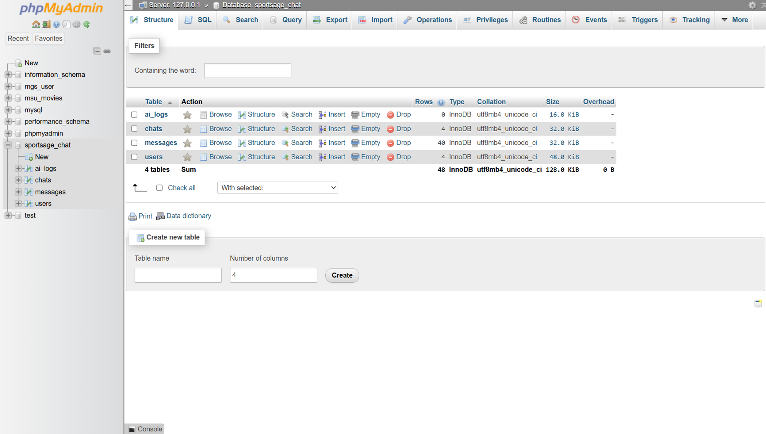

- User Table Structure:
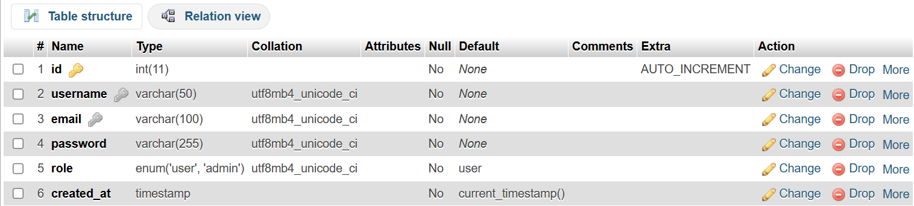

- Message Table Structure:
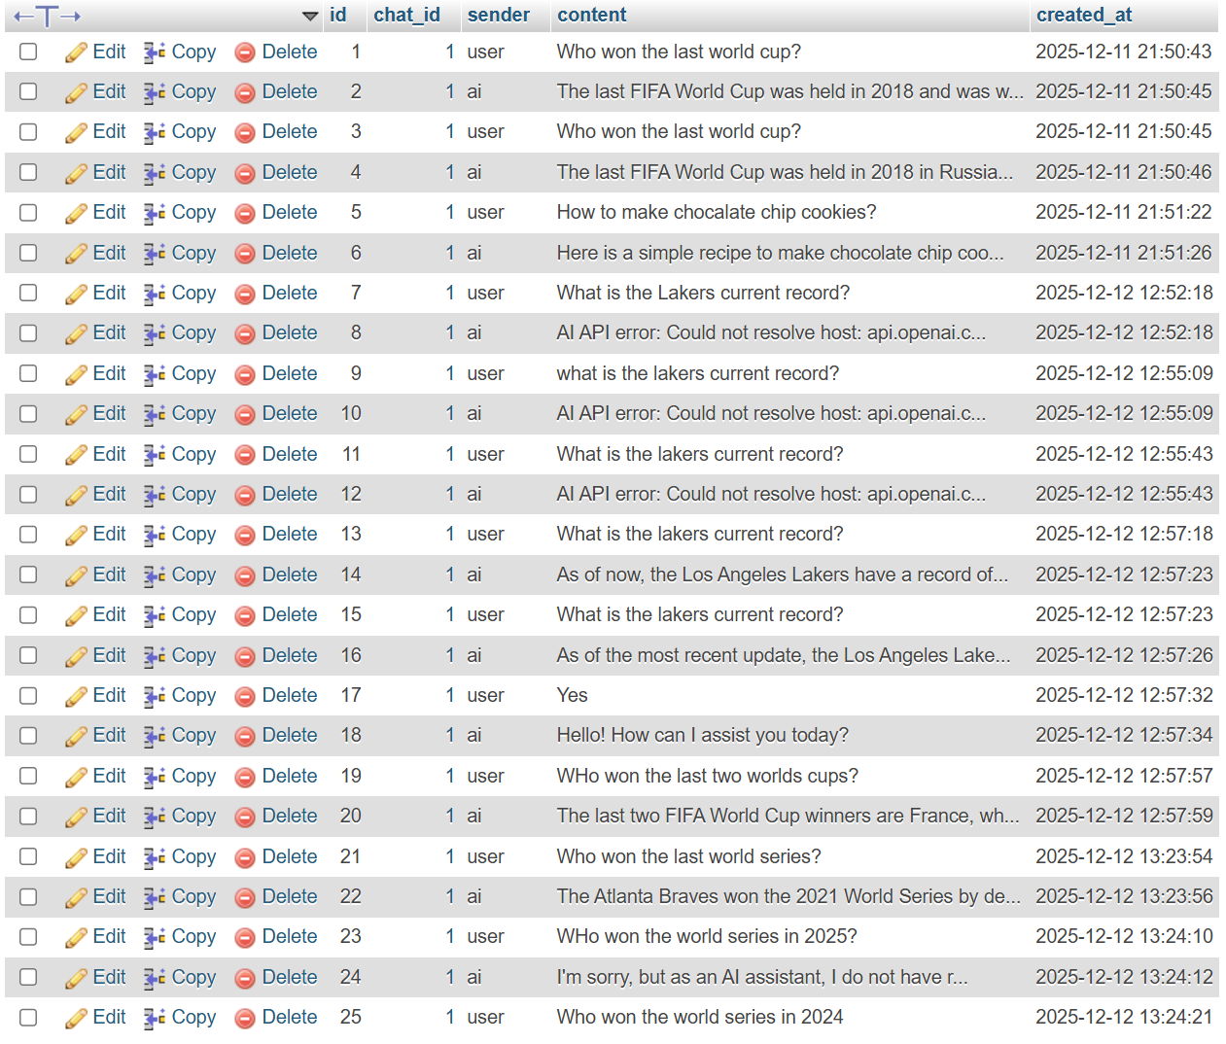

- SQL Database file:
-- phpMyAdmin SQL Dump
-- version 5.2.1
-- https://www.phpmyadmin.net/
--
-- Host: 127.0.0.1
-- Generation Time: Dec 12, 2025 at 07:58 PM
-- Server version: 10.4.32-MariaDB
-- PHP Version: 8.2.12

SET SQL_MODE = "NO_AUTO_VALUE_ON_ZERO";
START TRANSACTION;
SET time_zone = "+00:00";

/*!40101 SET @OLD_CHARACTER_SET_CLIENT=@@CHARACTER_SET_CLIENT */;
/*!40101 SET @OLD_CHARACTER_SET_RESULTS=@@CHARACTER_SET_RESULTS */;
/*!40101 SET @OLD_COLLATION_CONNECTION=@@COLLATION_CONNECTION */;
/*!40101 SET NAMES utf8mb4 */;

--
-- Database: `sportsage_chat`
--

-- --------------------------------------------------------

--
-- Table structure for table `ai_logs`
--

CREATE TABLE `ai_logs` (
`id` int(11) NOT NULL,
`chat_id` int(11) DEFAULT NULL,
`request` text DEFAULT NULL,
`response` text DEFAULT NULL,
`created_at` timestamp NOT NULL DEFAULT current_timestamp()
) ENGINE=InnoDB DEFAULT CHARSET=utf8mb4 COLLATE=utf8mb4_unicode_ci;

-- --------------------------------------------------------

--
-- Table structure for table `chats`
--

CREATE TABLE `chats` (
`id` int(11) NOT NULL,
`user_id` int(11) NOT NULL,
`title` varchar(255) DEFAULT 'New Chat',
`created_at` timestamp NOT NULL DEFAULT current_timestamp()
) ENGINE=InnoDB DEFAULT CHARSET=utf8mb4 COLLATE=utf8mb4_unicode_ci;

--
-- Dumping data for table `chats`
--

INSERT INTO `chats` (`id`, `user_id`, `title`, `created_at`) VALUES
(1, 1, 'My First Chat', '2025-12-12 02:07:52'),
(2, 2, 'My First Chat', '2025-12-12 02:22:57'),
(3, 3, 'My First Chat', '2025-12-12 18:31:23'),
(4, 4, 'My First Chat', '2025-12-12 18:35:20');

-- --------------------------------------------------------

--
-- Table structure for table `messages`
--

CREATE TABLE `messages` (
`id` int(11) NOT NULL,
`chat_id` int(11) NOT NULL,
`sender` enum('user','ai','admin') NOT NULL,
`content` text NOT NULL,
`created_at` timestamp NOT NULL DEFAULT current_timestamp()
) ENGINE=InnoDB DEFAULT CHARSET=utf8mb4 COLLATE=utf8mb4_unicode_ci;

--
-- Dumping data for table `messages`
--

INSERT INTO `messages` (`id`, `chat_id`, `sender`, `content`, `created_at`) VALUES
(1, 1, 'user', 'Who won the last world cup?', '2025-12-12 02:50:43'),
(2, 1, 'ai', 'The last FIFA World Cup was held in 2018 and was won by the French national football team. They defeated Croatia 4-2 in the final to claim their second World Cup title.', '2025-12-12 02:50:45'),
(3, 1, 'user', 'Who won the last world cup?', '2025-12-12 02:50:45'),
(4, 1, 'ai', 'The last FIFA World Cup was held in 2018 in Russia, and the winner was the French national team.', '2025-12-12 02:50:46'),
(5, 1, 'user', 'How to make chocalate chip cookies?', '2025-12-12 02:51:22'),
(6, 1, 'ai', 'Here is a simple recipe to make chocolate chip cookies:\n\nIngredients:\n- 1 cup (2 sticks) unsalted butter, softened\n- 1 cup granulated sugar\n- 1 cup packed light-brown sugar\n- 2 large eggs\n- 1 teaspoon vanilla extract\n- 3 cups all-purpose flour\n- 1 teaspoon baking soda\n- 1/2 teaspoon baking powder\n- 1/2 teaspoon salt\n- 2 cups semisweet and/or milk chocolate chips\n\nInstructions:\n1. Preheat your oven to 350Â°F (175Â°C) and line baking sheets with parchment paper.\n2. In a large mixing bowl, cream together the butter, granulated sugar, and brown sugar until light and fluffy.\n3. Beat in the eggs one at a time, then stir in the vanilla extract.\n4. In a separate bowl, whisk together the flour, baking soda, baking powder, and salt. Gradually add this dry mixture to the wet ingredients, mixing until well combined.\n5. Stir in the chocolate chips until evenly distributed throughout the dough.\n6. Drop rounded spoonfuls of dough onto the prepared baking sheets, leaving some space between each cookie.\n7. Bake in the preheated oven for 10-12 minutes, or until the edges are lightly golden. The centers may still look slightly undercooked, but they will continue to set as they cool.\n8. Allow the cookies to cool on the baking sheets for a few minutes before transferring them to a wire rack to cool completely.\n\nEnjoy your homemade chocolate chip cookies!', '2025-12-12 02:51:26'),
(7, 1, 'user', 'What is the Lakers current record?', '2025-12-12 17:52:18'),
(8, 1, 'ai', 'AI API error: Could not resolve host: api.openai.com', '2025-12-12 17:52:18'),
(9, 1, 'user', 'what is the lakers current record?', '2025-12-12 17:55:09'),
(10, 1, 'ai', 'AI API error: Could not resolve host: api.openai.com', '2025-12-12 17:55:09'),
(11, 1, 'user', 'What is the lakers current record?', '2025-12-12 17:55:43'),
(12, 1, 'ai', 'AI API error: Could not resolve host: api.openai.com', '2025-12-12 17:55:43'),
(13, 1, 'user', 'What is the lakers current record?', '2025-12-12 17:57:18'),
(14, 1, 'ai', 'As of now, the Los Angeles Lakers have a record of 24 wins and 27 losses in the current NBA season.', '2025-12-12 17:57:23'),
(15, 1, 'user', 'What is the lakers current record?', '2025-12-12 17:57:23'),
(16, 1, 'ai', 'As of the most recent update, the Los Angeles Lakers have a record of X wins and Y losses. Would you like me to look up the exact numbers for you?', '2025-12-12 17:57:26'),
(17, 1, 'user', 'Yes', '2025-12-12 17:57:32'),
(18, 1, 'ai', 'Hello! How can I assist you today?', '2025-12-12 17:57:34'),
(19, 1, 'user', 'WHo won the last two worlds cups?', '2025-12-12 17:57:57'),
(20, 1, 'ai', 'The last two FIFA World Cup winners are France, who won in 2018, and Germany, who won in 2014.', '2025-12-12 17:57:59'),
(21, 1, 'user', 'Who won the last world series?', '2025-12-12 18:23:54'),
(22, 1, 'ai', 'The Atlanta Braves won the 2021 World Series by defeating the Houston Astros.', '2025-12-12 18:23:56'),
(23, 1, 'user', 'WHo won the world series in 2025?', '2025-12-12 18:24:10'),
(24, 1, 'ai', 'I\'m sorry, but as an AI assistant, I do not have real-time information. You can check the latest updates on the 2025 World Series winner by searching online or checking with a sports news website. Let me know if you need help with anything else!', '2025-12-12 18:24:12'),
(25, 1, 'user', 'Who won the world series in 2024', '2025-12-12 18:24:21'),
(26, 1, 'ai', 'I\'m sorry, but I am not able to provide real-time information as I do not have access to the internet. I recommend checking a reliable sports news website or app for the most up-to-date information on the 2024 World Series winner.', '2025-12-12 18:24:23'),
(27, 1, 'user', 'Who won the world series 10 years ago?', '2025-12-12 18:24:44'),
(28, 1, 'ai', 'The St. Louis Cardinals won the World Series in 2011, defeating the Texas Rangers in a thrilling seven-game series.', '2025-12-12 18:24:46'),
(29, 1, 'user', 'Who won the world series in 2000?', '2025-12-12 18:24:59'),
(30, 1, 'ai', 'The New York Yankees won the World Series in 2000. They defeated the New York Mets in the Subway Series, winning the series 4-1.', '2025-12-12 18:25:01'),
(31, 4, 'user', 'In the year 2005, who won the world series?', '2025-12-12 18:35:34'),
(32, 4, 'ai', 'In 2005, the Chicago White Sox won the World Series by defeating the Houston Astros.', '2025-12-12 18:35:36'),
(33, 4, 'user', 'In 2016 who won the world cup?', '2025-12-12 18:36:04'),
(34, 4, 'ai', 'The 2018 FIFA World Cup was won by France. Germany won the 2014 FIFA World Cup.', '2025-12-12 18:36:06'),
(35, 4, 'user', 'Which country won the 2010 world cup?', '2025-12-12 18:37:13'),
(36, 4, 'ai', 'The 2010 FIFA World Cup was won by Spain. They defeated the Netherlands 1-0 in the final to claim their first World Cup title.', '2025-12-12 18:37:14'),
(37, 2, 'user', 'When was the infamous superbowl in 2013?', '2025-12-12 18:38:15'),
(38, 2, 'ai', 'The infamous Super Bowl that took place in 2013 was Super Bowl XLVII, held on February 3, 2013. The game was played between the Baltimore Ravens and the San Francisco 49ers.', '2025-12-12 18:38:17'),
(39, 1, 'user', 'WHo won the 2020 nba championship', '2025-12-12 18:47:24'),
(40, 1, 'ai', 'The Los Angeles Lakers won the 2020 NBA Championship.', '2025-12-12 18:47:26');

-- --------------------------------------------------------

--
-- Table structure for table `users`
--

CREATE TABLE `users` (
`id` int(11) NOT NULL,
`username` varchar(50) NOT NULL,
`email` varchar(100) NOT NULL,
`password` varchar(255) NOT NULL,
`role` enum('user','admin') NOT NULL DEFAULT 'user',
`created_at` timestamp NOT NULL DEFAULT current_timestamp()
) ENGINE=InnoDB DEFAULT CHARSET=utf8mb4 COLLATE=utf8mb4_unicode_ci;

--
-- Dumping data for table `users`
--

INSERT INTO `users` (`id`, `username`, `email`, `password`, `role`, `created_at`) VALUES
(1, 'Joshua', 'joshua@gmail.com', '$2y$10$DbAVjajLUXpY7PfoOZtIQuTv4AUkoA/.6yxoIqlFOejmJ.mbMm8uu', 'user', '2025-12-12 01:58:24'),
(2, 'admin', 'admin@sportsage.com', '$2y$10$DhekRnjJBiO3kxv4t8apju90lSFD62AC.VBNi.yIgO/fibcU7HR/e', 'admin', '2025-12-12 02:09:06'),
(3, 'TestUser', 'testuser@gmail.com', '$2y$10$/ePpqdlIZzySo2jmGzrqq.bdu5ttOYAe.YAP/T35NF9sUb2aDRPEK', 'user', '2025-12-12 18:31:15'),
(4, 'Student1', 'student1@gmail.com', '$2y$10$b2UIWTZVH7sq/1lIvEJgeOvucgZlAgAwxkaefk3CSpr.1VHEtsGj.', 'user', '2025-12-12 18:35:01');

--
-- Indexes for dumped tables
--

--
-- Indexes for table `ai_logs`
--
ALTER TABLE `ai_logs`
ADD PRIMARY KEY (`id`);

--
-- Indexes for table `chats`
--
ALTER TABLE `chats`
ADD PRIMARY KEY (`id`),
ADD KEY `user_id` (`user_id`);

--
-- Indexes for table `messages`
--
ALTER TABLE `messages`
ADD PRIMARY KEY (`id`),
ADD KEY `chat_id` (`chat_id`);

--
-- Indexes for table `users`
--
ALTER TABLE `users`
ADD PRIMARY KEY (`id`),
ADD UNIQUE KEY `username` (`username`),
ADD UNIQUE KEY `email` (`email`);

--
-- AUTO_INCREMENT for dumped tables
--

--
-- AUTO_INCREMENT for table `ai_logs`
--
ALTER TABLE `ai_logs`
MODIFY `id` int(11) NOT NULL AUTO_INCREMENT;

--
-- AUTO_INCREMENT for table `chats`
--
ALTER TABLE `chats`
MODIFY `id` int(11) NOT NULL AUTO_INCREMENT, AUTO_INCREMENT=5;

--
-- AUTO_INCREMENT for table `messages`
--
ALTER TABLE `messages`
MODIFY `id` int(11) NOT NULL AUTO_INCREMENT, AUTO_INCREMENT=41;

--
-- AUTO_INCREMENT for table `users`
--
ALTER TABLE `users`
MODIFY `id` int(11) NOT NULL AUTO_INCREMENT, AUTO_INCREMENT=5;

--
-- Constraints for dumped tables
--

--
-- Constraints for table `chats`
--
ALTER TABLE `chats`
ADD CONSTRAINT `chats_ibfk_1` FOREIGN KEY (`user_id`) REFERENCES `users` (`id`) ON DELETE CASCADE;

--
-- Constraints for table `messages`
--
ALTER TABLE `messages`
ADD CONSTRAINT `messages_ibfk_1` FOREIGN KEY (`chat_id`) REFERENCES `chats` (`id`) ON DELETE CASCADE;
COMMIT;

/*!40101 SET CHARACTER_SET_CLIENT=@OLD_CHARACTER_SET_CLIENT */;
/*!40101 SET CHARACTER_SET_RESULTS=@OLD_CHARACTER_SET_RESULTS */;
/*!40101 SET COLLATION_CONNECTION=@OLD_COLLATION_CONNECTION */;

